DR. MAHALINGAM COLLEGE OF ENGINEERING AND TECHNOLOGY, POLLACHI.



DEPARTMENT OF ELECTRONICS AND COMMUNICATION ENGINEERING.

19ECCN1701
RF AND MICROWAVE ENGINEERING
ASSIGNMENT – 02

DESIGN AND SIMULATION OF AN
E-PLANE TEE USING CST

SUBMITTED BY,
ADHIL M(727622BEC114).
SITHISH KUMAR K (727622BEC116)
ECE-B

ABSTRACT

The E-Plane Tee, also known as a series tee, is an essential microwave junction used to divide or combine power in rectangular waveguide systems. This project focuses on the design, simulation, and analysis of an E-Plane Tee using CST Microwave Studio (CST MWS). The E-plane Tee is designed based on standard rectangular waveguide dimensions (WR-90 or similar) operating in the dominant TE₁₀ mode.

In this work, a 3D model of the E-Plane Tee is constructed in CST, defining parameters such as waveguide width, height, and junction arm length. The structure is simulated to evaluate S-parameters (S₁₁, S₂₁, S₃₁) to observe power division, reflection coefficient, and isolation characteristics. Proper impedance matching techniques and optimization tools within CST are employed to minimize return loss and achieve balanced power division between output arms.

The simulation results demonstrate the electromagnetic field distribution, current flow, and scattering matrix behavior, confirming the theoretical performance of the E-Plane Tee. The designed component shows good matching and low insertion loss at the operating frequency band, making it suitable for use in microwave circuits, power dividers, and balanced mixer applications.

This project highlights the importance of CST as a powerful tool for microwave component design, analysis, and optimization, providing both qualitative and quantitative insights into the behavior of waveguide junctions.

OBJECTIVE

The main objective of this project is to design and analyze an E-Plane Tee using CST Microwave Studio (CST MWS). The study aims to model the E-Plane Tee structure operating in the dominant TE₁₀ mode and to examine its scattering parameters (S₁₁, S₂₁, S₃₁) to evaluate reflection, transmission, and isolation characteristics.

The project also focuses on studying the electric and magnetic field distributions within the waveguide junction to understand the behavior of signal splitting and phase reversal. Additionally, the objective is to achieve proper impedance matching, ensuring minimum return loss and maximum power transfer. The simulated results are compared with theoretical analysis to validate the performance and confirm the effectiveness of the E-Plane Tee as a microwave power divider and phase-splitting component.

E-PLANE DESIGN

An E-Plane Tee, also known as a waveguide tee, is a fundamental microwave component used for power division or combination in rectangular waveguide systems. It is constructed by connecting a third waveguide (side arm) to the main waveguide (collinear arms), forming a structure that resembles the letter “T” — hence the name “Tee”.

In an E-Plane Tee, the axis of the side arm is parallel to the electric field (E-field) of the main waveguide. This orientation gives the device its name — E-Plane Tee. The Tee functions as a three-port junction, typically labeled as Port 1, Port 2, and Port 3.

When a signal is applied to Port 3 (the side arm), it divides equally into Ports 1 and 2, but the output signals are 180° out of phase with each other due to the field symmetry. Conversely, when equal signals of the same phase are applied to Ports 1 and 2, the outputs cancel out at Port 3. This property makes the E-Plane Tee useful as a microwave power divider, mixer, or phase shifter in RF and microwave systems.

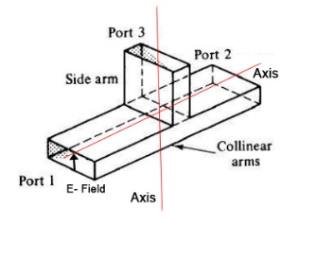

The figure below represents the basic structure of an E-Plane Tee, showing the orientation of the electric field and the waveguide arms.

E-Plane Tee Circuit Model

Co-Axial Cable:

The ports of an E-Plane Tee are connected to other components of the circuit using a co-axial cable. Proper termination of co-axial cable is necessary to ensure impedance matching. The co-axial cable should be able to match the characteristic impedance of Tee. This is how cable ensures proper signal transmission.

E-Plane Tee:

The E-Plane Tee forms one essential component of the circuit. It performs the task of combining or splitting the input wave depending on the application it is being used for. The input is generally fed at port 3 and then the Tee splits the input to generate output at the two ports, port 1 and port 2.

Terminations:

At the end of each port reflections can occur and distort the signals therefore terminations are applied to minimize signal loss through reflections. This is how power is transmitted efficiently.

Signal Monitoring:

A probe can be used to measure the signal at certain points. The probe is connected in a way such that it helps to test the signal at a specific port without causing any trouble to the signal.

DIFFERENCE BETWEEN E-PLANE AND H-PLANE TEES
Parameter | E-Plane Tee | H-Plane Tee
Figure | 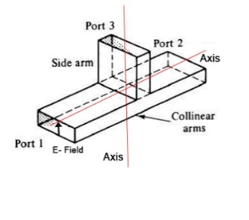 | 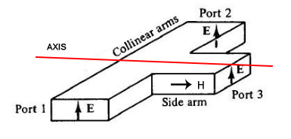
Definition | The E-Plane Tee is a waveguide junction in which the side arm is connected parallel to the electric field (E-plane) of the main waveguide. It is also called a Series Tee. | The H-Plane Tee is a waveguide junction in which the side arm is connected parallel to the magnetic field (H-plane) of the main waveguide. It is also known as a Shunt Tee.
Field Orientation | The side arm lies in the E-field plane, which is the plane containing the electric field lines. | The side arm lies in the H-field plane, which contains the magnetic field lines.
Waveguide Mode | Operates mainly in the TE₁₀ mode of rectangular waveguides. | Also operates in the TE₁₀ mode, but coupling occurs through the H-field.
Relationship to Each Other | Produces 180° phase difference between the two output ports (Port 1 and Port 2). | Produces 0° phase difference between the two output ports.
Electric Field | The electric field divides equally but reverses polarity between the two collinear arms. | The electric field in both collinear arms remains in phase and has the same direction.
Magnetic Field | The magnetic field is perpendicular to the plane of the junction. | The magnetic field lies in the plane of the junction, resulting in smooth current flow.
Wave Propagation | Acts as a series junction—voltage divides, current remains the same. | Acts as a parallel junction—current divides, voltage remains the same.
Phase Relationship | Outputs are out of phase (180°). | Outputs are in phase (0°).
Power Division | Splits input power equally but with opposite polarity at output ports. | Splits input power equally and in phase at output ports.
Impedance Matching | Difficult due to E-field discontinuity at the junction. | Easier because of continuous H-field lines at the junction.
Applications | Used in phase comparison, balanced mixers, and modulators. | Used in power dividers, power combiners, and antenna feeds.
Typical Losses | Higher reflection and insertion losses if not matched properly. | Lower reflection losses and better matching characteristics.
Use in Hybrid Junctions | Used along with H-Plane Tee to form a Magic Tee (Hybrid Tee). | Used along with E-Plane Tee to form a Magic Tee (Hybrid Tee).

ADVANTAGES OF E-PLANE TEE

Combining and Splitting Capability:

The E-Plane Tee can both combine and split microwave power, making it highly useful in power distribution networks.

Low Cross-Coupling:

Its configuration provides minimal coupling between arms, ensuring good isolation and reducing interference between ports.

Symmetrical Structure:

The symmetrical design simplifies construction and ensures identical output characteristics, regardless of the input port used.

Compact Size:

The small and lightweight structure allows easy integration into microwave and RF circuits, where space is a constraint.

Wide Frequency Range:

The E-Plane Tee operates efficiently over a broad range of frequencies, making it suitable for various microwave applications.

Stable Performance:

Provides consistent amplitude and phase balance across ports, which is essential for balanced mixers and hybrid circuits.

APPLICATIONS

Microwave power dividers and combiners

Balanced mixers and modulators

Phase shifting networks

Bridge circuits and magic tees

Microwave antenna feed systems

Design Procedure

1. Create a New Project:

Open CST Microwave Studio and start a new project. Choose “Microwave & RF / Waveguide” as the application type. This sets the correct solver and environment for high-frequency waveguide analysis.

2. Set Frequency Range:

Specify the operating frequency range — typically 8–12 GHz for X-band applications. This ensures that the simulation results cover the entire range where the E-plane Tee is expected to operate efficiently.

3. Draw the Main Waveguide:

Create the rectangular main waveguide using the ‘Brick’ tool.

Set the waveguide dimensions according to the WR-90 standard (Width = 22.86 mm, Height = 10.16 mm) or use the custom parameters defined (e.g., a = 11 mm, b = 6 mm, etc.). This forms the main transmission line of the structure.

4. Add the Side Arm (E-Plane):

Insert a perpendicular waveguide arm to the main section along the E-plane (the plane containing the electric field).

This side arm forms the “T” structure. The side arm’s axis should be parallel to the E-field of the main waveguide to achieve proper E-plane Tee operation.

5. Assign Material:

Select all waveguide parts and assign the material as PEC (Perfect Electric Conductor). This ensures that the boundaries perfectly reflect electromagnetic waves and simulate ideal metallic walls with no losses.

6. Define Ports:

Assign waveguide ports at all three openings — Port 1, Port 2, and Port 3 — to allow signal excitation and observation. Typically, Port 3 acts as the input port, while Ports 1 and 2 serve as the output ports.Ensure proper port orientation to align with the field propagation direction.

7. Meshing and Simulation:

Generate a hexahedral mesh to discretize the geometry for numerical computation. Then, run the frequency-domain solver to simulate the electromagnetic behavior of the structure. CST computes the field distribution, reflection coefficients, and transmission characteristics.

8. View and Analyze Results:

After simulation, observe and analyze results such as:

S-parameters (S11, S21, S31) to evaluate reflection and transmission.

Electric and magnetic field distributions to visualize power flow and field orientation.

Current density plots to identify surface current flow and confirm proper excitation.

These results verify the correct operation of the E-plane Tee as a power divider/combiner, confirming good matching, symmetry, and low cross-coupling.

DESIGN OF E PLANE TEE

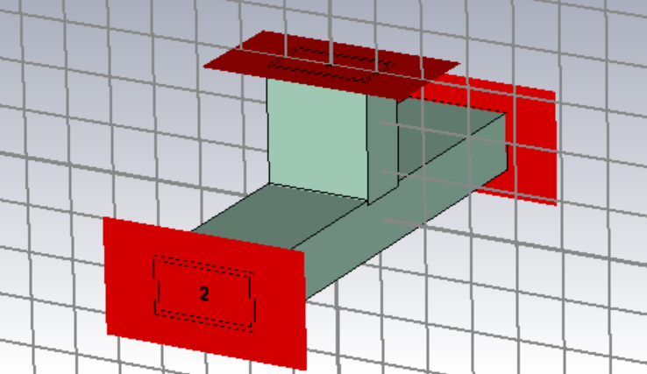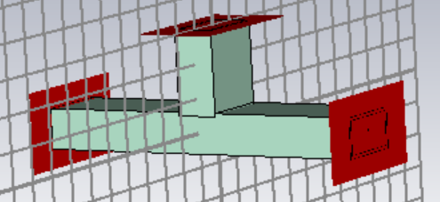

Three dimensional view of an E-plane Tee.

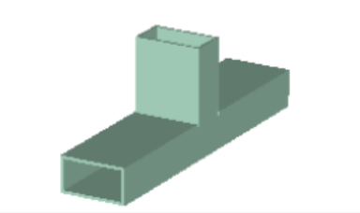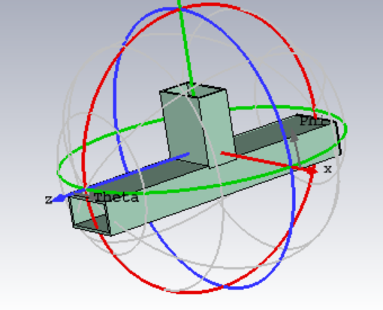

Schematics view of E Plane Tee

Design Parameters
In CST Microwave Studio, the E-Plane Tee is modeled using parametric dimensions to allow flexible modification and optimization. The key parameters defining the geometry are shown in Table 1.
Parameter | Expression | Value (mm) | Description
a | = 11 | 11 | Width of the rectangular waveguide
b | = 6 | 6 | Height of the rectangular waveguide
c | = 50 | 50 | Depth or length of the waveguide arm
d | = 11 | 11 | Half distance between Xmin and Xmax
e | = 12.5 | 12.5 | Half distance between Ymax and Ymin
f | = 6 | 6 | Half distance between Zmax and Zmin

Result and Discussion

The E-Plane Tee was designed and simulated using CST Microwave Studio to analyze its performance in terms of S-parameters, field distribution, and power division characteristics. The simulation was carried out in the X-band frequency range (8–12 GHz), using the waveguide dimensions specified in the parameter table.

1D RESULT

S-PARAMETER

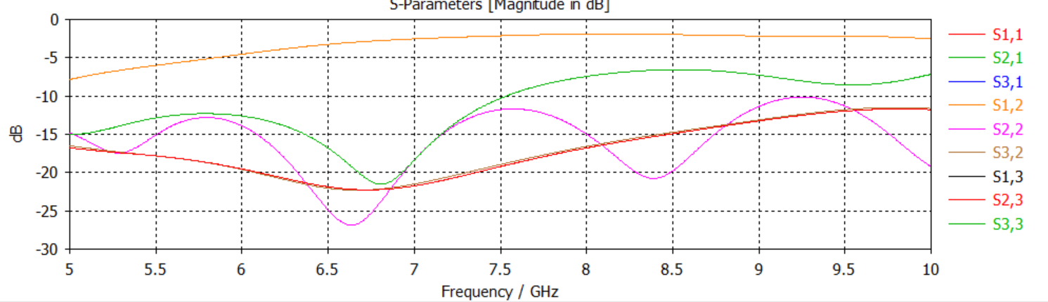

POWER

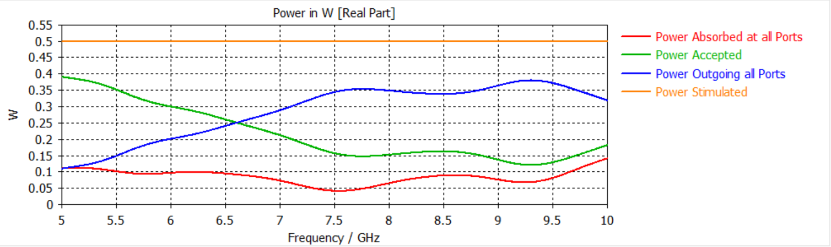

ENERGY

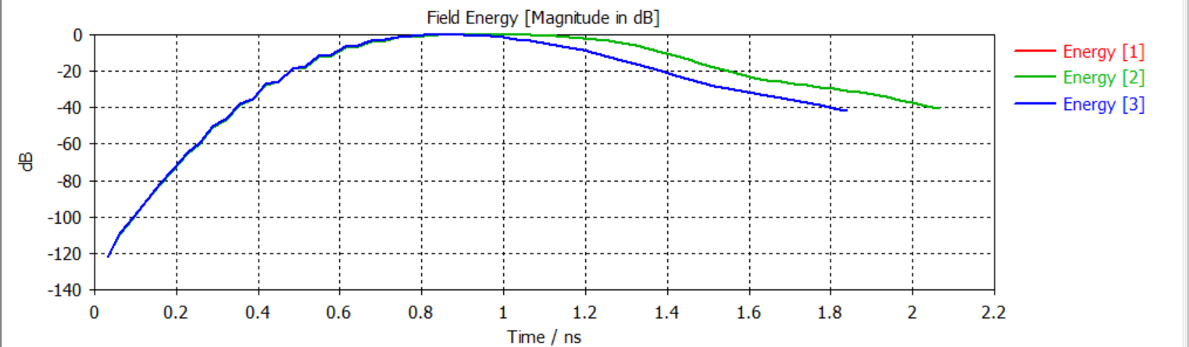

2D RESULT (Electric Field Distribution)

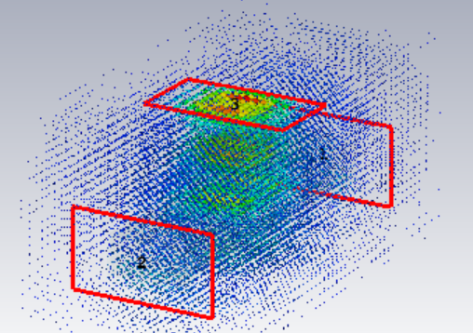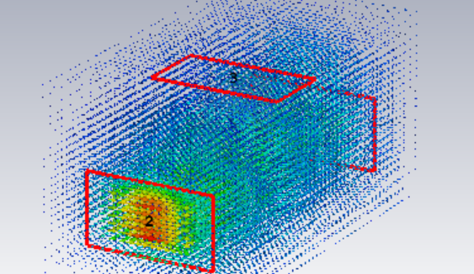

CONCLUSION

The design and simulation of the E-Plane Tee were successfully carried out using CST Microwave Studio. The results demonstrate that the E-Plane Tee effectively splits the input signal power equally between the two output arms, confirming its role as a power divider. The electric field distribution clearly showed strong field intensity along the E-plane, validating the theoretical behavior of the component.

The simulated S-parameters indicated good impedance matching and low reflection losses at the operating frequency, proving the accuracy of the design parameters used. The structure exhibited symmetrical field patterns, low cross-coupling, and efficient power transmission, making it suitable for use in microwave circuits and waveguide networks.

Overall, the CST simulation verified that the designed E-Plane Tee performs according to theory and can be effectively used for power division and combining applications in microwave systems. Future improvements could include optimization for a wider bandwidth and enhanced isolation.

